**Experiment : 1.4**

**Student Name: SANJIV GUPTA UID:** 21BCS-*3478*

**Branch:** CSE **Section/Group:** 21BCS-IOT-602B

**Semester:** 5th **Date:** 15/09/23

**Subject Name**: Advanced Programming LAB **Subject Code:** 21CSP-314

**AIM:**

*Sorting and Searching: Implement the concept of Searching and Sorting techniques.*

**OBJECTIVE:**

*1: Given two arrays of integers, find which elements in the second array are missing from the first array.*

*2: Lauren has a chart of distinct projected prices for a house over the next several years. She must buy the house in one year and sell it in another, and she must do so at a loss. She wants to minimize her financial loss.*

**CODE:**

**Code 1:**

*import math*

*import os*

*import random*

*import re*

*import sys*

*def missingNumbers(arr, brr, values=[]):*

*brr_1 = set(brr)*

*for i in brr_1:*

*a = arr.count(i)*

*b = brr.count(i)*

*if a < b:*

*values.append(i)*

*return values*

*if __name__ == 'main':*

*fptr = open(os.environ['OUTPUT_PATH'], 'w')*

*n = int(input().strip())*

*arr = list(map(int, input().rstrip().split()))*

*m = int(input().strip())*

*brr = list(map(int, input().rstrip().split()))*

*result = missingNumbers(arr, brr)*

*fptr.write(' '.join(map(str, result)))*

*fptr.write('\n')*

*fptr.close()*

**Code 2**

*import math*

*import os*

*import random*

*import re*

*import sys*

*def minimumLoss(price):*

*r_index = sorted(range(len(price)), key=lambda x: price[x], reverse=True)*

*min_loss = 10**16*

*for i in range(len(r_index)-1):*

*if r_index[i] < r_index[i+1]:*

*index1 = r_index[i]*

*index2 = r_index[i+1]*

*loss = price[index1] - price[index2]*

*min_loss = min(min_loss, loss)*

*return min_loss*

*if __name__ == 'main':*

*fptr = open(os.environ['OUTPUT_PATH'], 'w')*

*n = int(input().strip())*

*price = list(map(int, input().rstrip().split()))*

*result = minimumLoss(price)*

*fptr.write(str(result) + '\n')*

*fptr.close()*

**OUTPUT:**

**OUTPUT 1**

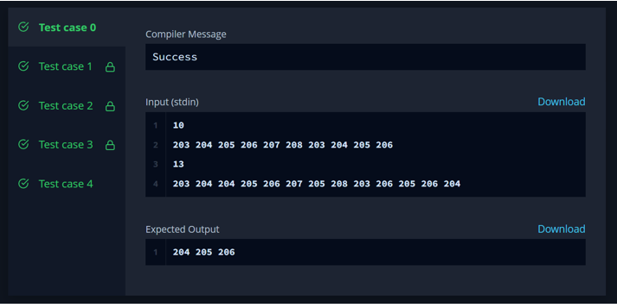

**OUTPUT 2**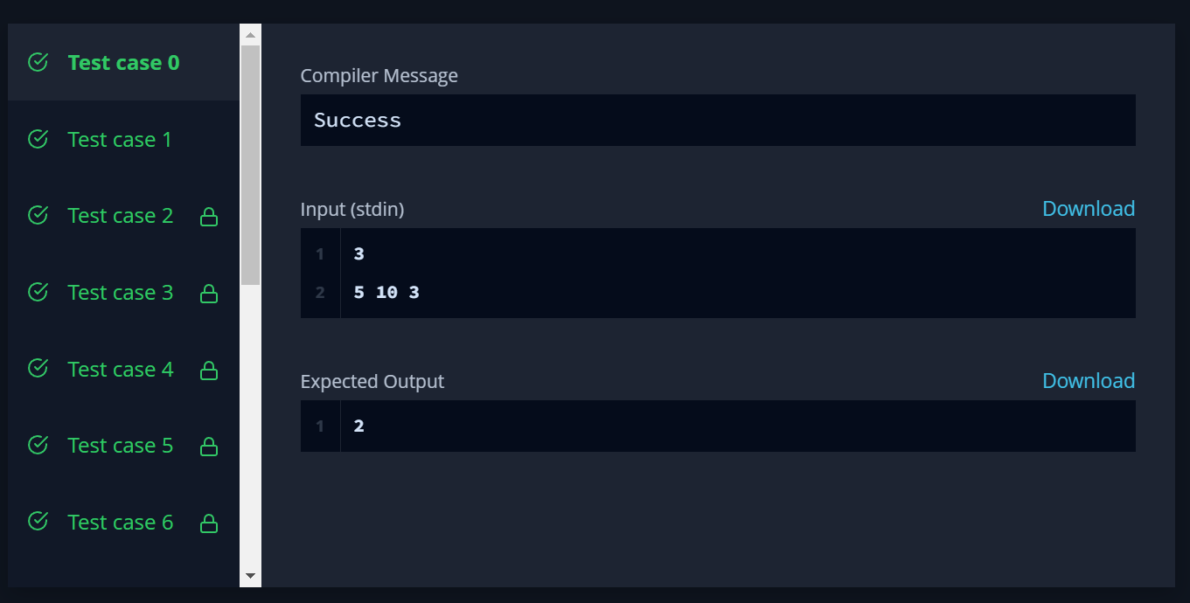

**LEARNING OUTCOMES:**

1. *Understood the concept of searching and sorting.*
2. *Understood the concept how to search and sort elements.*
3. *Learn about algorithm thinking*
4. *Learn about mathematical logic*